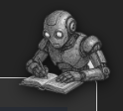

AI Revision Bot Admin Manual
Version 0.3.2 – Simon Rundell (simonrundell@exe-coll.ac.uk)
April 2026

Includes the User Manual at the beginning.



Login Screen:
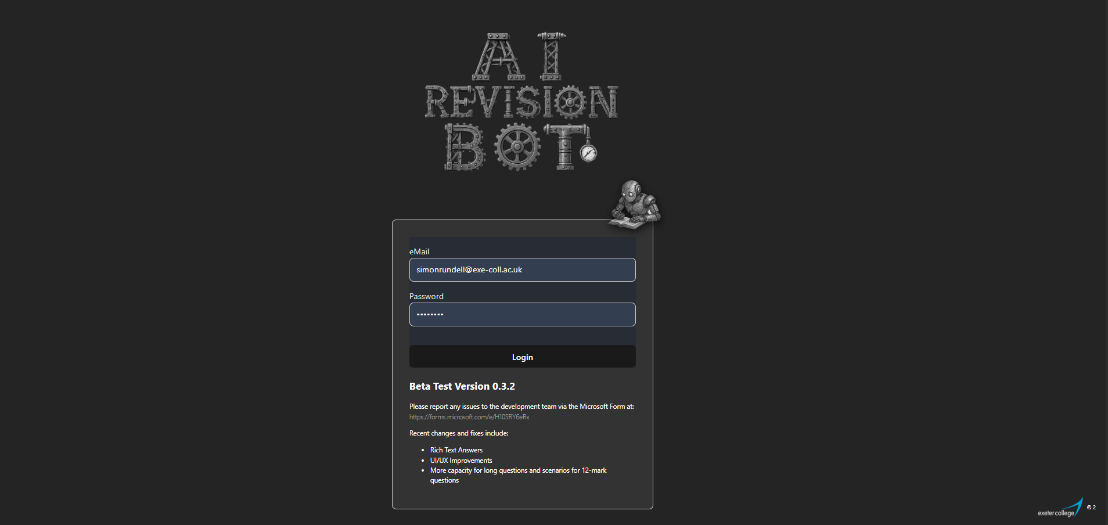

If you haven’t logged in before, your login is your college email address and the default password will be told you by your teacher. You are advised to change your password as soon as possible through “My Profile” once you are logged in. Remember your password because resetting it requires your teacher to do it manually for you.

Dashboard
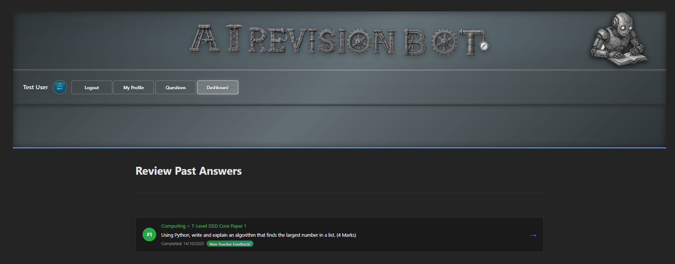
The Dashboard is where you begin using the AI Revision Bot. You can change your password and screen avatar in the “My Profile” section (overleaf).
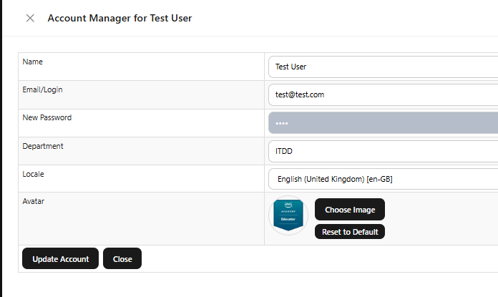
By clicking on each previously answered questions you will be able to see what you answered and also see the feedback from the AI and a Red, Amber Green rating and an optional comment from your teacher.
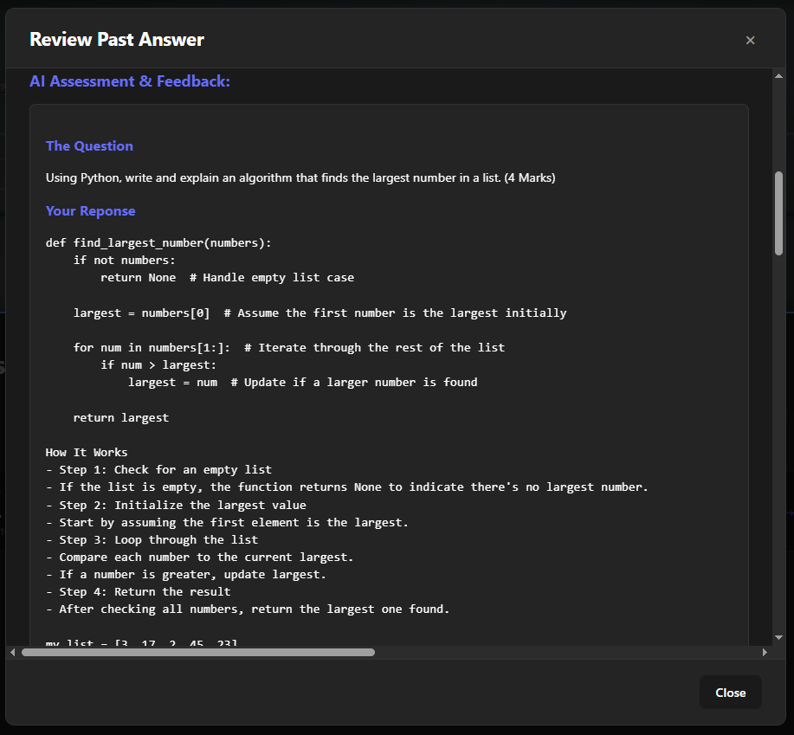
You can have another go at each question as many times as you like to perfect your answer and improve your learning.

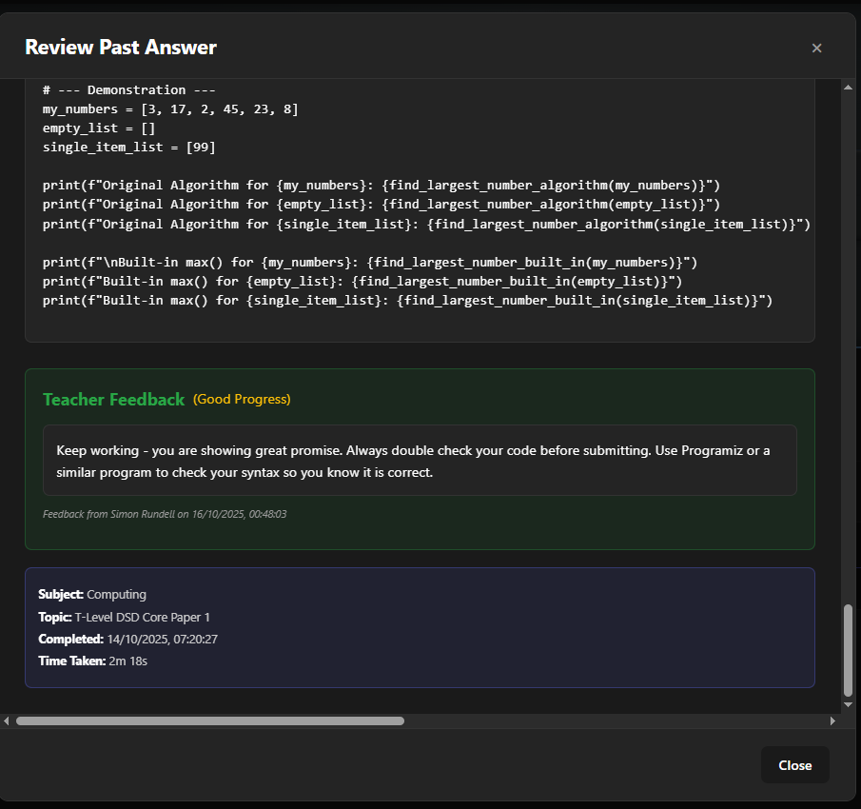

Answering Questions
Click on the “Questions” button on the Dashboard to practice some questions and get almost instant feedback from an AI to help your revision.
Firstly, select a subject:
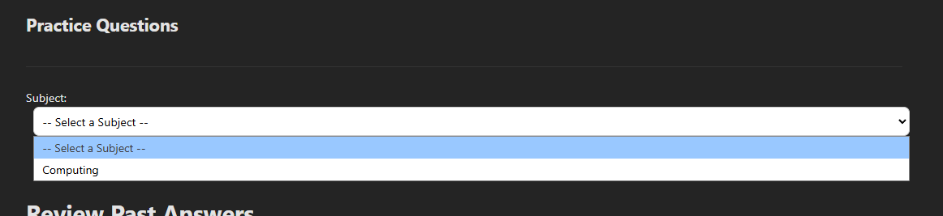
Then select a topic within that subject:
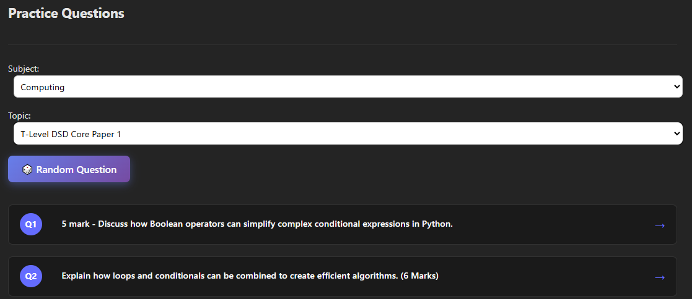
You can opt for a random question or choose one from the list. There are usually between 30 and 100 questions on each topic.
Click on that question to answer it.
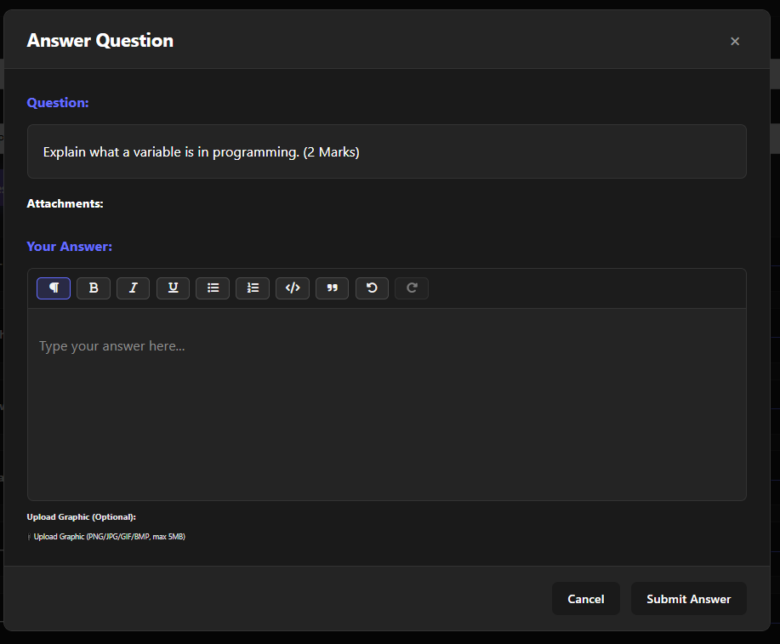

Notice that the answer box enables you to format your answer. You can make text bold, italic or underlined or a combination of all three. You can also make ordered lists (ie 1,2,3) and unordered lists (ie bullet points). You can mark code to make it standout in a monospace font and use blockquotes. There is also the “Undo” and “Redo” buttons.
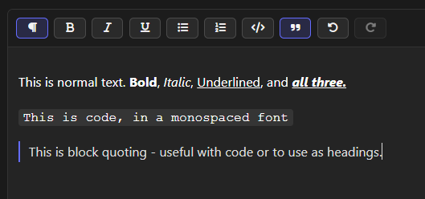

You will not be able to cut and paste answers in, to minimise the use of AI or copypasta.
The AI refuses to be swayed off topic, so don’t try to do it. Firstly it will reject nonsense answers that are not appropriate; it will refuse to deliver information outside of feedback and remember each answer is shown to a teacher who will know! Don’t waste your valuable revision time trying to do this.
Some questions allow you to upload an image – perhaps a flowchart which you have drawn using a charting program. This will be uploaded and both the AI and the teacher will examine it as part of your answer.
When you submit your answer there will be a few seconds of pause and then you will be given feedback on your answer including pointers for improvement and a model answer. This will all be sent to the teacher for a Red, Amber Green Review, which you can see in the main list on your Dashboard.

Admin Guide
This section covers parts not accessible to students.
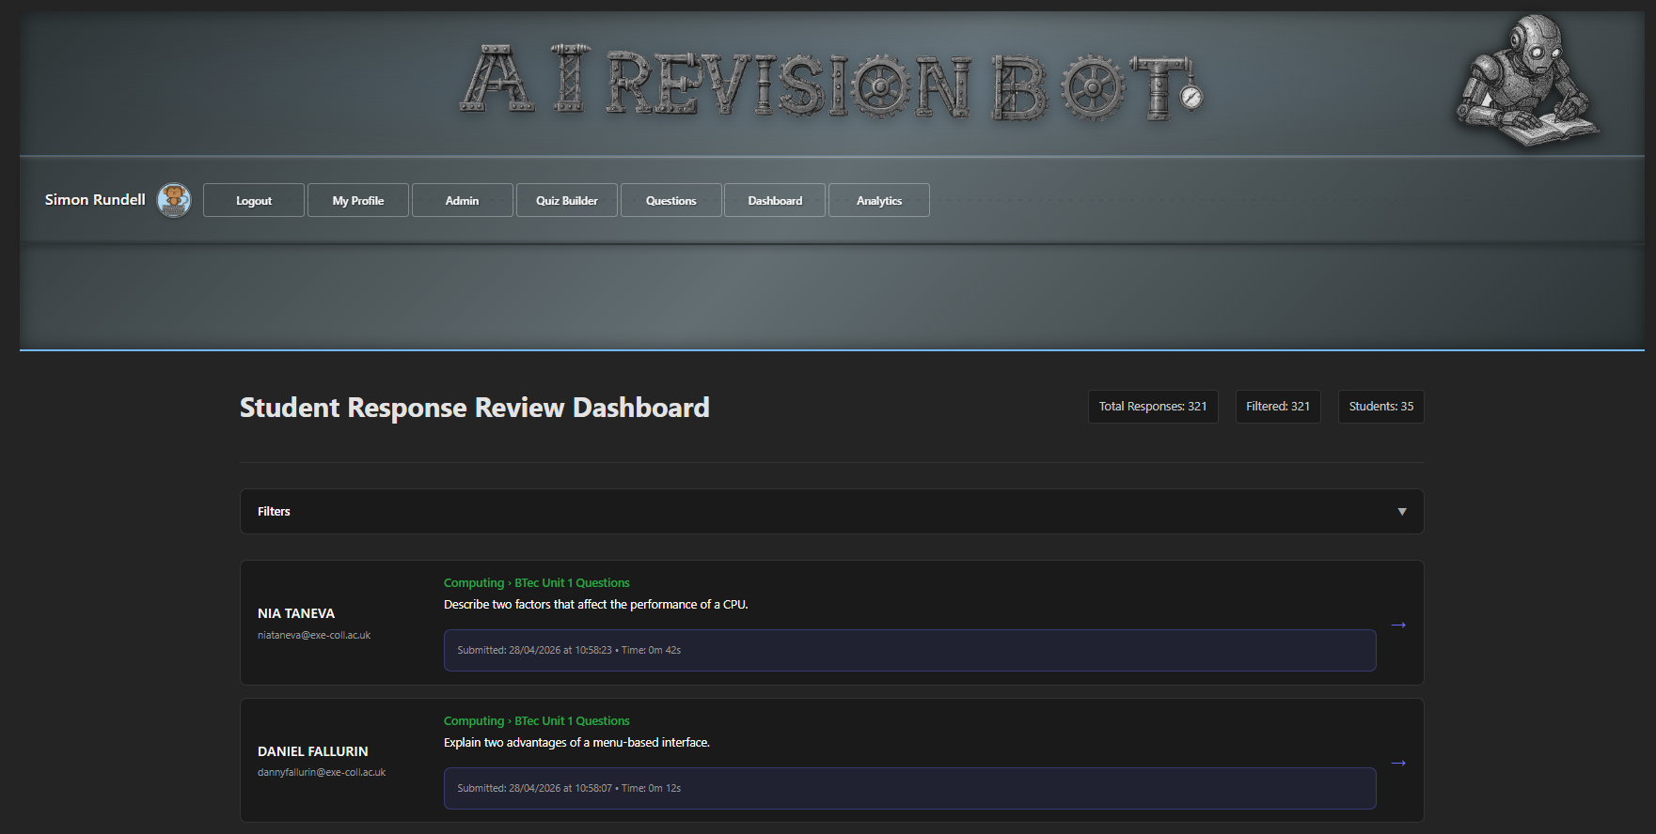

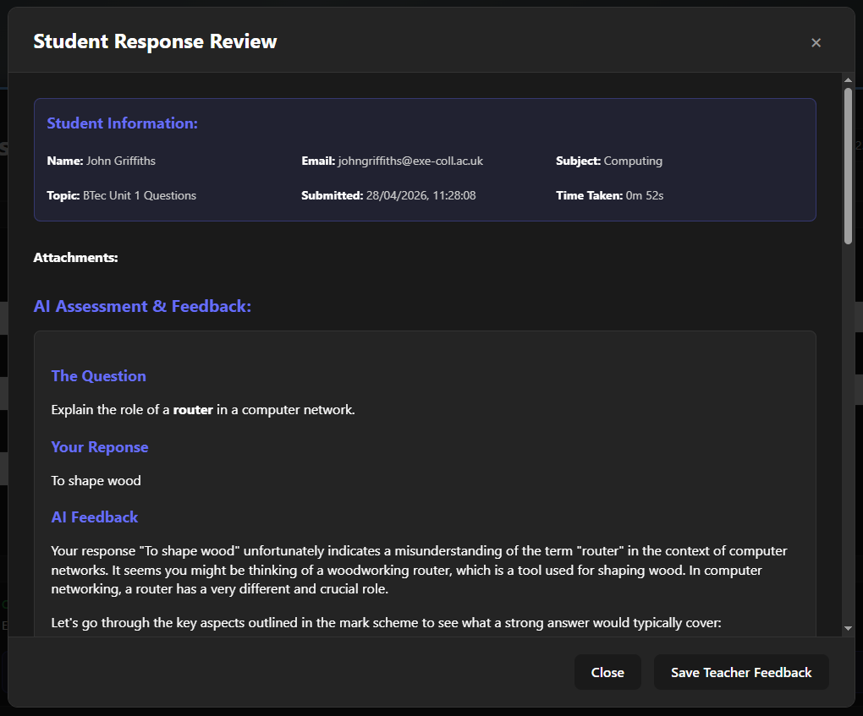
Teachers/Admins see a different Dashboard when they login. It shows the most recently answered questions. By clicking on the “filters” dropdown, the teacher can see answers for specific students, answers between specified dates, all or just unanswered questions and responses to specific subjects or topics.
COMING SOON Filtering by Class will shortly be available.
Clicking on a question opens up details about that question, including how long a student spent on the question. It reproduces the question, answer and AI feedback.

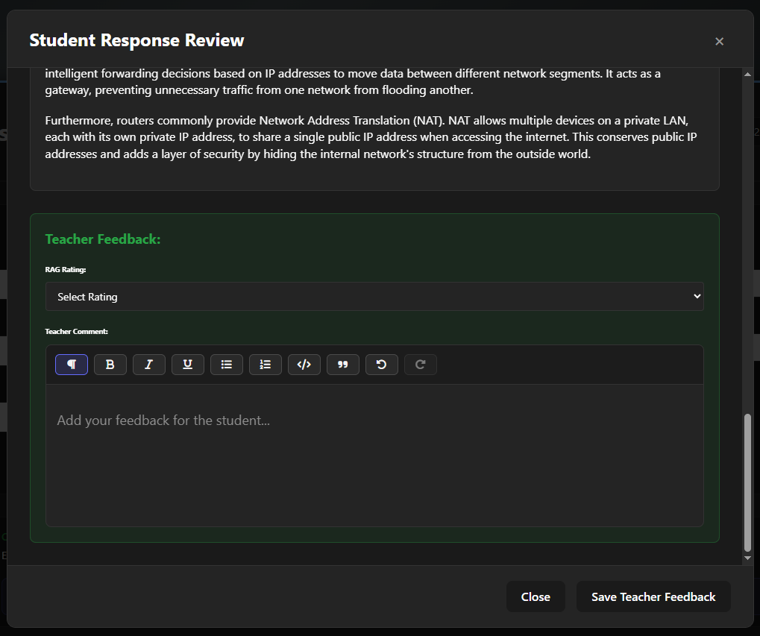
At the bottom, the Teacher can give a Red-Amber-Green rating to a response and make any comments or marks they would wish to give. When the feedback is saved, it is recorded and the student will see that on their Dashboard.

Admin of Students
The Admin button displays all students, which can be filtered
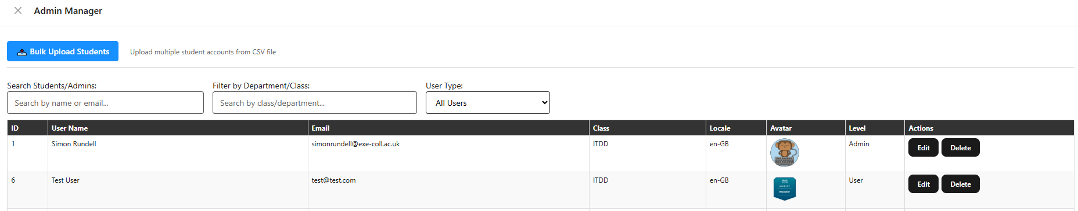
Clicking on edit enables the individual user to be modified.

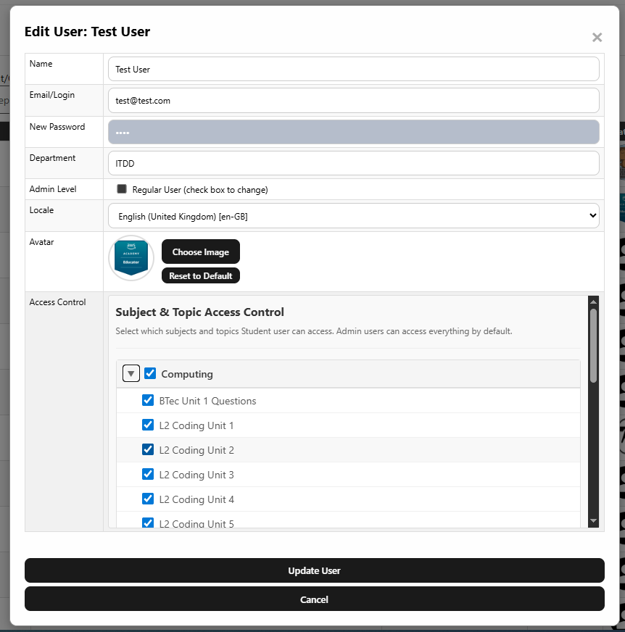
The password can be changed by typing a new password into the password box.
You can also restrict a student’s access to individual subjects or topics, and change their avatar.
The data will not be updated until you click on “Update User”.
New students can be added using the “bulk upload” button and it contains specific instructions on the format and process.

Quiz Builder
This is where questions are created or modified. This includes the mark scheme which is used by the AI for feedback.

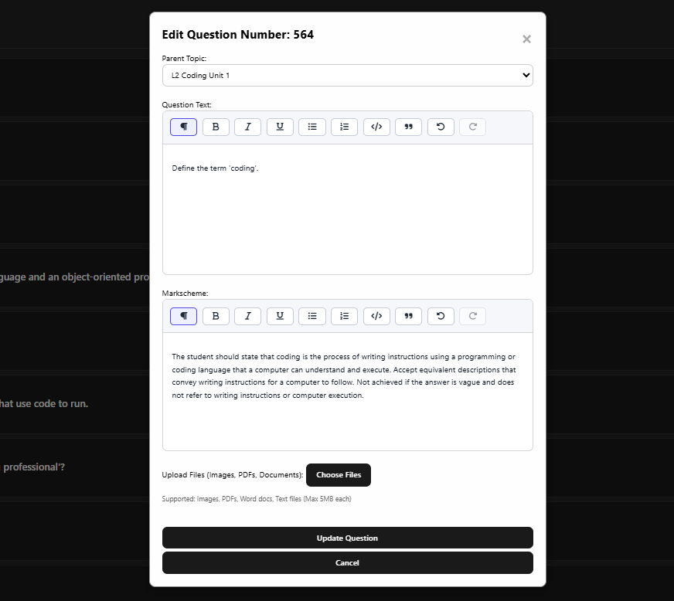
Clicking on a question, or the “Add Question” button at the bottom will enable you to edit or add a question and the mark scheme. You will see that the mark scheme should be formative and enable the AI to build a constructive feedback.

Adding Subjects and Topics
The AI Revision Bot is suitable for any subject for which there are paragraph-level questions. To add a subject, select “Add New Subject”. To add a top, select “Add New Topic”
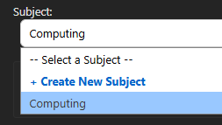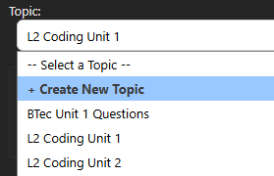

Bulk Questions
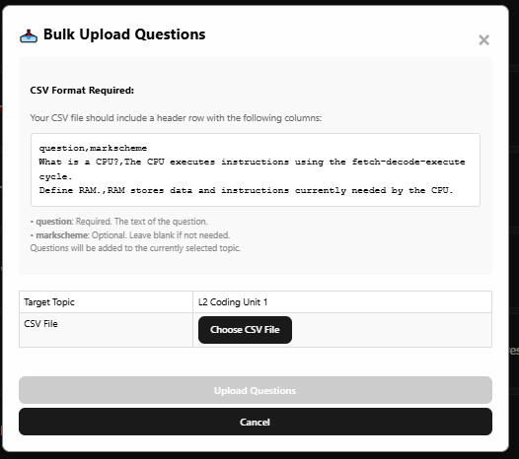
I recommend producing the data in Excel and saving it as “CSV (UTF-8)” format

Bulk Students
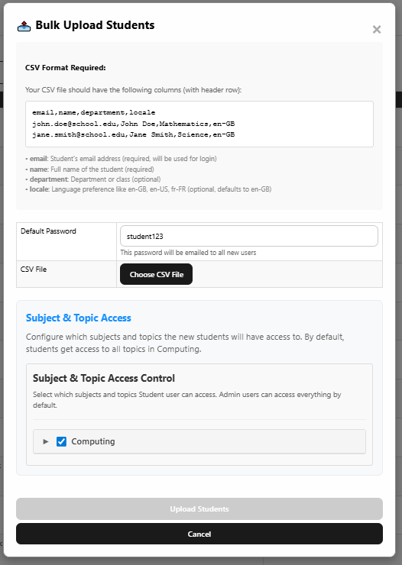

I recommend producing the data in Excel and saving it as “CSV (UTF-8)” format

Further Information/Support

Simon Rundell, eMail: simonrundell@exe-coll.ac.uk
Programme Leader Tel: 07976 802123
Dept of ITDD
Victoria House
Exeter College
Queen Street EX4 3SR

The first batch of students tried, of course, and so it is now battle hardened. Don’t waste your time.

